Historic Huguenot Street and Vassar College Present:
Camerata Trajectina Concert
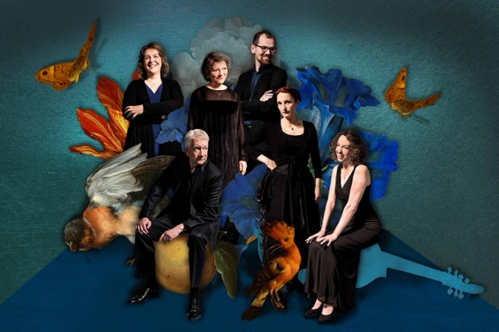
NEW PALTZ, NY (September 15, 2023) – Camerata Trajectina, the “Musical Treasury of the Netherlands,” has announced their upcoming tour to the United States. From October 7 – 11, 2023, audiences will have three chances to see the group as they tour the Hudson Valley and New York City, making stops at three of the region’s most well-known and respected educational institutions.

Camerata Trajectina programs combine popular songs of the 17th century with works of the great Renaissance and Baroque composers, often presented against a political, literary, or artistic backdrop. For nearly 50 years, they have performed countless times at national memorials and royal visits, made nearly 50 recordings, and were awarded an Edison Klassiek prize for their recording of the Antwerp Songbook.

For this program, Camerata teams up with Dr. Jaap Jacobs, an eminent historian and author of Dutch New York. The combination of Camerata’s long experience in recreating 17th-century Dutch music and Jacobs’s historical expertise ensures the audience an exhilarating and unforgettable musical experience.

Camerata Musician Cassandra Luckhardt says, “I am always very excited to come back to my native country to perform, as American audiences are something very special. There's a warmth and an appreciation that is so genuine. Bringing Dutch music back to the original Dutch settlements is extremely satisfying in closing the circle.”

The Camerata Trajectina will play at the New York State Museum's Huxley Theater in Albany at 4:00 PM on Saturday, October 7th as part of the New Netherland Institute's, 45th Annual Conference, "Get a Sense of New Netherland: Approaching the Dutch Colony through Sight, Sound, Taste, and Touch." Registration for this daylong program, which includes talks by historians, an opportunity to learn about and touch replica objects, as well as a performance by the Indigenous Spirit Dancers of the Seneca Nation, is $50.

On Sunday, October 8th, Camerata Trajectina will perform at 3:00 PM in Poughkeepsie, NY at the beautiful Skinner Hall of Music, as Historic Huguenot Street and Vassar College bring this spectacular program to the public, free of charge. Registration for this event is available at: https://www.huguenotstreet.org/calendar-of-events/2023/10/08/camerata-trajectina

On Wednesday, October 11th, from 6:30 – 8:30 PM, Camerata Trajectina will perform the final program of their tour in New York City, at the Morgan Library & Museum, co-presented by the New Amsterdam History Center. Tickets are $35 for general admission and $25 for Morgan and New Amsterdam History Center members and are available at: https://newamsterdamhistoryceter.org/events/camerata-trajectina-concert-with-narration-by-jaap-jacobs/

This program is supported by the Dutch Culture USA program of the Consulate General of the Kingdom of the Netherlands in New York.

Image Credit: Camerata Trajectina. Photography by Foppe Schut, artwork by Sophie van Boven, Green Room Creatives.

About Historic Huguenot Street
A National Historic Landmark District, Historic Huguenot Street (HHS) is a 501(c)3 non-profit dedicated to preserving a pre-Revolutionary Hudson Valley settlement and engaging diverse audiences in the exploration of America's multicultural past, in order to understand the historical forces that have shaped America. As an educational institution founded by the town’s French-speaking Protestant descendants and chartered by the University of the State of New York Department of Education, HHS explores the lives of the early European colonists, honors the region’s Indigenous people, and acknowledges the enslaved and disenfranchised peoples who built this place. Today, HHS is recognized as an innovative museum and community gathering place, providing visitors with an inclusive presentation of our shared past. For more information visit www.huguenotstreet.org.
About the New Amsterdam History Center
The mission of the New Amsterdam History Center (NAHC) is to encourage exploration of the Dutch history of New Amsterdam as it laid the foundational character for today’s New York City, with special reference to its ethnic, racial, and religious diversity, urban landscapes, economic vitality, and global legacy. NAHC fulfills its mission by linking the past to the present through public lectures and panel discussions, concerts, newsletters, tours, and online research resources all of which since 2005 have enriched public understanding of the continuing Dutch contributions to New York City. Our Mapping Early New York, is a treasure trove of information about New Amsterdam from detailed sources connected with map features. https://newamsterdamhistorycenter.org/

About New Netherland Institute
The New Netherland Institute (NNI) is a registered 501 (c)(3) non-profit organization. Our mission is to preserve, digitize, and translate Dutch documents related to New Netherland and its connections in the seventeenth and eighteenth centuries. We also support public programming and scholarly research that sheds light on the Dutch history of North America. https://www.newnetherlandinstitute.org/

###

Sarah Levy
Marketing & Communications Coordinator
media@huguenotstreet.org
(845) 255-1660 Ext. 102

