Haunted Huguenot Street:
A Poisoning at The Budd Hotel
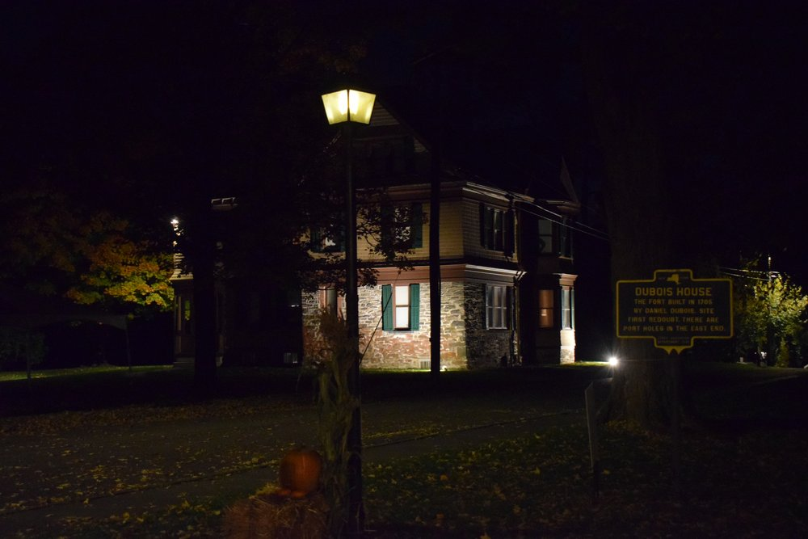
NEW PALTZ, NY (October 3, 2023) – Friday the 13th of October will mark the opening night of this year’s Haunted Huguenot Street program, which will immerse visitors in the mysterious, true case of the Budd family’s attempted murder. Nearly 250 years ago, someone tried to poison the family that ran New Paltz's first hotel. The crime, aftermath, and trial gripped the attention of the region, yet the story was almost lost to history... until now. Visitors who attend this program will participate in solving the mystery of who poisoned the Budd family.
This interactive theater experience will last approximately one hour. Tours will depart from the DuBois Fort Visitor Center every hour on the hour beginning at 5 PM, with the last tour departing at 8 PM.
Our program discusses topics such as death and murder. Parental supervision is required for children under 13.
Tours will be taking place on Friday, October 13 – Saturday, October 14; Friday, October 20 – Saturday, October 21; and Friday, October 27 – Sunday, October 29. Sunday, October 29th tours will take place at the earlier time slots of 3 PM, 4 PM, 5 PM, and 6 PM.
For more information and to register please visit: https://www.huguenotstreet.org/calendar-of-events/2023/10/13/haunted-huguenot-street
Pre-registration is highly encouraged.
Visit www.huguenotstreet.org for information on other seasonal programming.
Haunted Halloween is sponsored by Ulster County
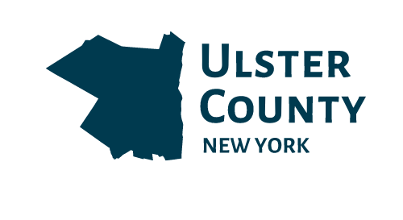
About Historic Huguenot Street
A National Historic Landmark District, Historic Huguenot Street (HHS) is a 501(c)3 non-profit dedicated to preserving a pre-Revolutionary Hudson Valley settlement and engaging diverse audiences in the exploration of America's multicultural past, in order to understand the historical forces that have shaped America. As an educational institution founded by the town’s French-speaking Protestant descendants and chartered by the University of the State of New York Department of Education, HHS explores the lives of the early European colonists, honors the region’s Indigenous people, and acknowledges the enslaved and disenfranchised peoples who built this place. Today, HHS is recognized as an innovative museum and community gathering place, providing visitors with an inclusive presentation of our shared past. For more information visit www.huguenotstreet.org.
###

Sarah Levy
Marketing & Communications Coordinator
media@huguenotstreet.org
(845) 255-1660 Ext. 102

