Historic Huguenot Street Presents "Soul of A Nation: Tribal Sovereignty and the American Revolution," a virtual presentation with Heather Bruegl & Chief Mark Peters
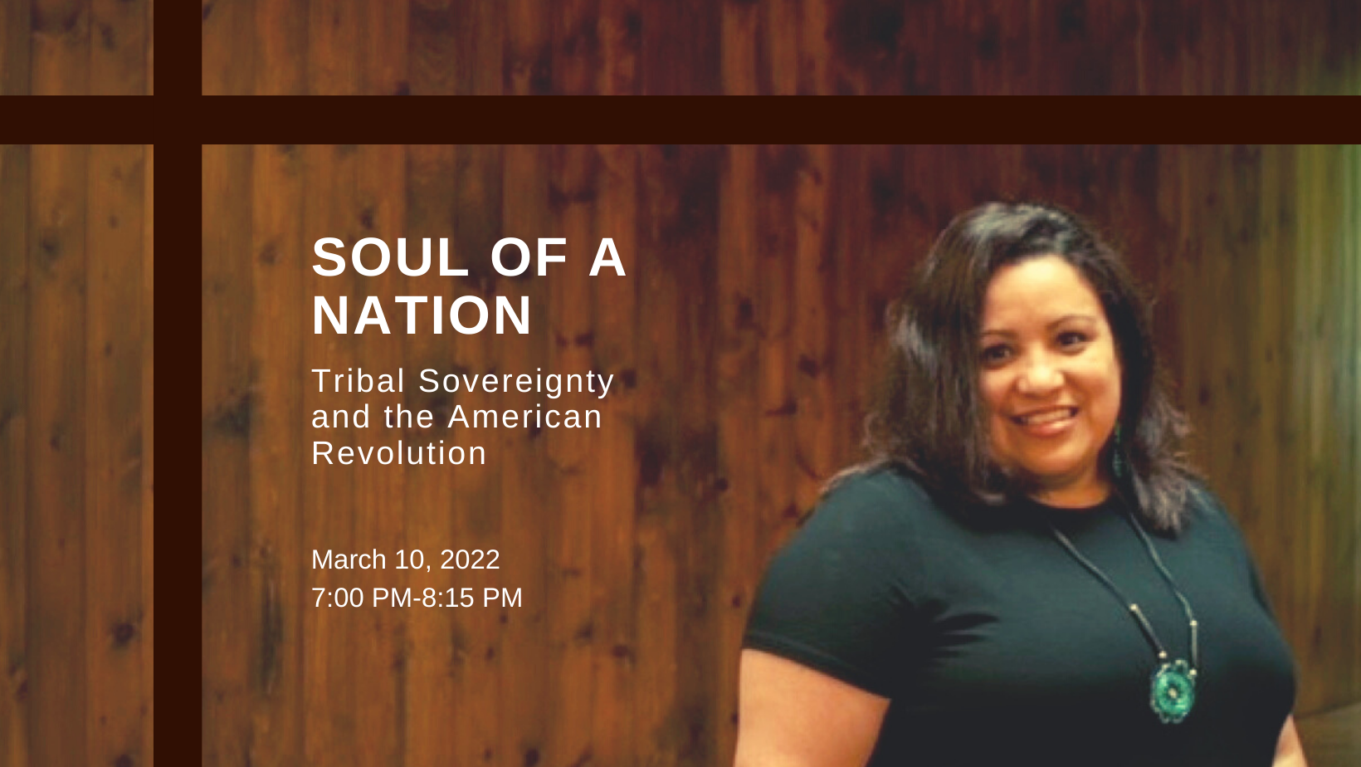

NEW PALTZ, NY (March 3, 2022) – Historic Huguenot Street presents “Soul of A Nation: Tribal Sovereignty and the American Revolution," a virtual presentation with Heather Bruegl & Chief Mark Peters. This program will take place on Thursday, March 10, 2022, from 7pm to 8:15pm. It will be presented entirely online.
For generations, we’ve been taught that the players of the American Revolution were made up of two teams: the British and the colonists - the Redcoats and the Patriots. But did you know that Native nations played major roles in both the fight for and against American independence? This presentation will examine how Indigenous groups, like the Munsee and the Mohicans, were either inspired or persuaded to take sides in the conflict, and explain how such decisions would go on to impact the course of their communities’ histories forever.
Heather Bruegl is a member of the Oneida Nation of Wisconsin and first line descendent Stockbridge-Munsee. She is a graduate of Madonna University in Michigan and holds a BA and MA in U.S. History. Inspired by a trip to Wounded Knee, South Dakota, a passion for Native American History was born. She has spoken for numerous universities including the University of Michigan, University of Wisconsin, and the College of the Menominee Nation. She opened for and spoke at the Women’s March Anniversary in Lansing, Michigan in 2018, at the first ever Indigenous Peoples March in Washington, DC in 2019, and at the Crazy Horse Memorial and Museum in Custer, South Dakota in 2019 and 2020. She is a self-proclaimed “accidental activist,” presenting on intergenerational racism and trauma, and helps to bring awareness to the environment, the fight for clean water, and other issues in the Native community. She now serves as the Director of Education for Forge Project located in Upstate New York.
Mark Peters is the Chief of the Munsee-Delaware Nation in Southwestern Ontario, Canada. He has been the historian for their community for the past 30 years. He has worked in the Logging Industry in the Queen Charlotte Islands, or Haida Gwaii, on an Oil and Natural Gas Rig, as a Social Worker, and in Criminal and Family Law as a Member of the Law Society of Ontario. In addition to History, his present focus is on determining and finding ways to exercise Inherent Indigenous Rights, which have been severely limited by Canadian Law over the past 150 years.
General Admission $8
Discounted Admission $5 (For HHS members, seniors, students, active military members, and veterans)
Questions related to the program, site accessibility, and current COVID-19 health and safety guidelines should be directed towards Kara Augustine, Director of Public Programming, at kara@huguenotstreet.org
Learn more and register at https://www.huguenotstreet.org/calendar-of-events/2022/3/10/soul-of-a-nation.
Sponsored by Lothrop Associates LLP
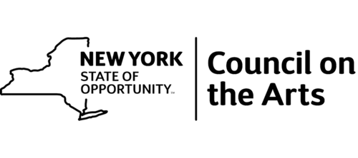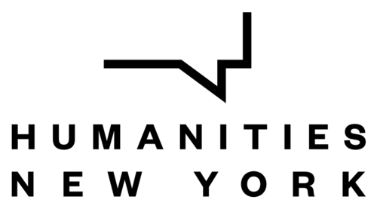
This program is made possible by the New York State Council on the Arts with the support of the Governor and the New York State Legislature.
This program is funded in part by a Humanities New York SHARP Grant with support from the National Endowment for the Humanities and the federal American Rescue Plan Act.
Any views, findings, conclusions or recommendations expressed in this program do not necessarily represent those of the National Endowment for the Humanities.

About Historic Huguenot Street
A National Historic Landmark District, Historic Huguenot Street is a 501(c)3 non-profit that encompasses 30 buildings across 10 acres comprising the heart of the original 1678 New Paltz settlement, including seven stone houses dating to the early eighteenth century. Historic Huguenot Street was founded in 1894 as the Huguenot Patriotic, Historical, and Monumental Society to preserve the nationally acclaimed collection of stone houses. Since then, Historic Huguenot Street has grown into an innovative museum, chartered as an educational corporation by the University of the State of New York Department of Education that is dedicated to preserving a unique Hudson Valley Huguenot settlement and engaging diverse audiences in the exploration of America's multicultural past in order to understand the historical forces that have shaped America.
###
Sarah Levy
Marketing & Communications Coordinator
sarahlevy@huguenotstreet.org
(845) 255-1660 Ext. 102

